Database Systems
Fall-2024 Department of Computer Science
The Islamia University Bahawalpur
Class 4th MA

Submitted by: (Khalid Ahmed, S23BDOCS1M01003)
Submitted to: Muhammad Usman Ghani

- Introduction:
  - Background:
The university_professors table contains information about professors, their affiliated universities, associated organizations, and the functions they perform. This single table has redundancy and lacks normalization, making it hard to manage and scale. By splitting it into four related tables — professors, universities, organizations, and affiliations — we aim to create a normalized structure that enhances data integrity and ensures scalability.
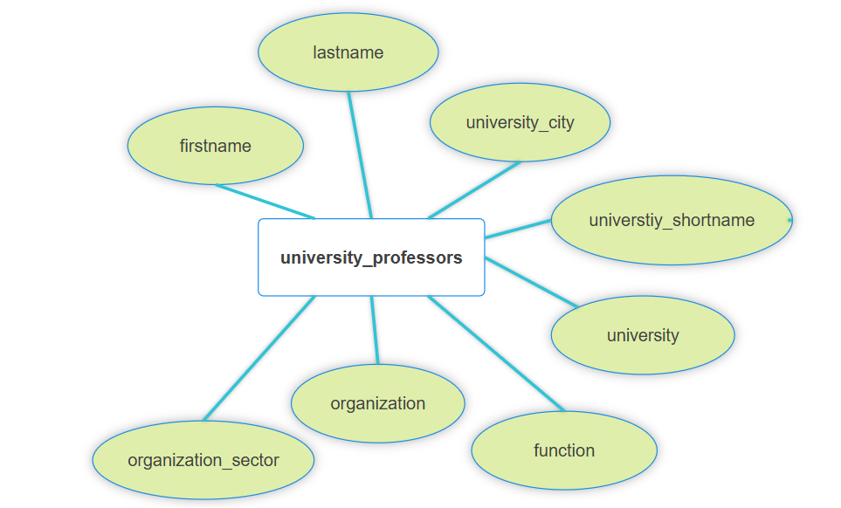
Figure 1 university_professors table with redundancy and lack of normalization.

  - Goal:
The goal is to create a normalized database structure by splitting the university_professors table into multiple tables, ensuring minimal redundancy and easy maintainability. The project aims to implement a robust schema, insert data, and demonstrate various SQL operations like joins, updates, and deletes.

  - Requirements:
- Store professor information (first name, last name, etc.).
- Store University details (short name, city, etc.).
- Track affiliations between professors and organizations.
- Ensure data integrity using primary and foreign keys.
- Allow querying for reports, such as professors by university or organization sector.

- Functional Description:
  - Method of use
This database will primarily be used by university administrators and researchers. Administrators can update professor affiliations, while researchers can query the database for insights, such as the distribution of professors by organization sector or city.

- Entity Data Model
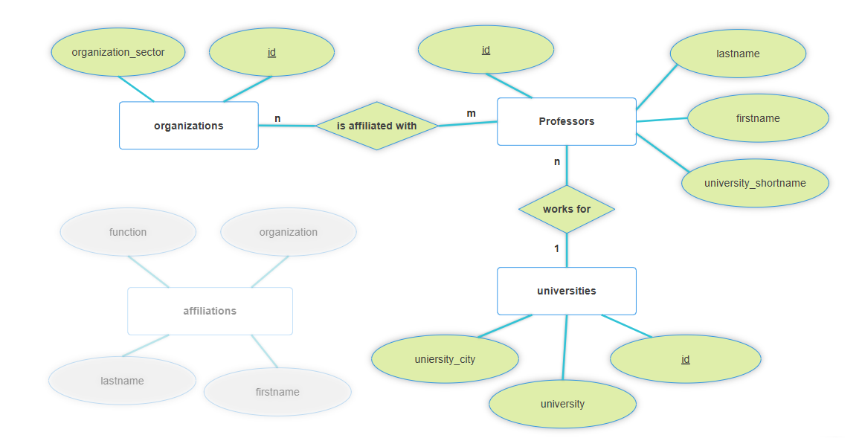
In the final schema, redundancy has been minimized by organizing the data into three tables: organizations, professors, and universities. The professors table is linked to the universities table through a foreign key, establishing a one-to-many relationship. Additionally, the organizations and professors tables are connected via the affiliations table, which implements a many-to-many relationship using foreign keys.

- Table Design (Schema) Screenshots
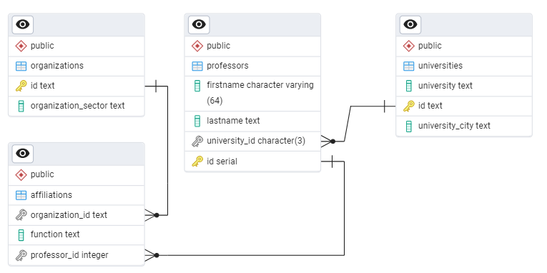
Table names:
Table Name | Primary key and Constraint | Foreign Key(s) | Unique Constraints
Professors | Id : professor_primary_key | Professors_fkey
Universities | Id: uni_primary_key |  | Unishortunq
Organizations | Id: organization_primary_key
Affiliations |  | Affiliations_organization_id_fkey  Affiliations_professor_id_fkey

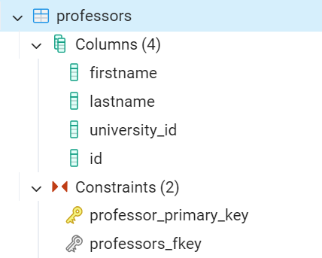
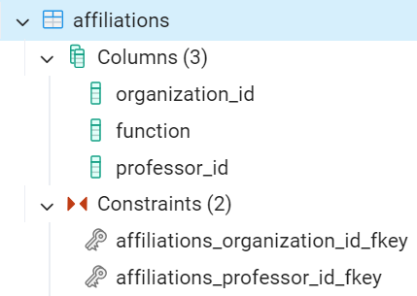

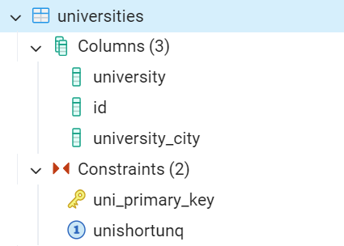
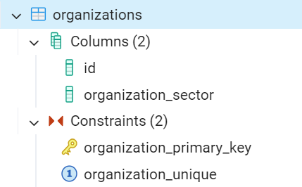

- Frontend Screenshots
Example Queries and the outputs (Create, Insert, Update, Delete, Joins, Referential integrity)

INSERT and REFERENTIAL INTEGRITY QUERY:
Inserting values with referential integrity. In which first we have to insert university then we can add a professor referencing university.
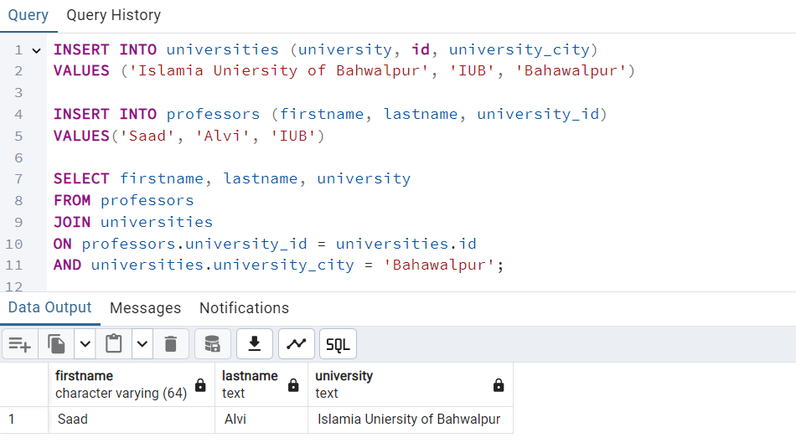

Delete Query:
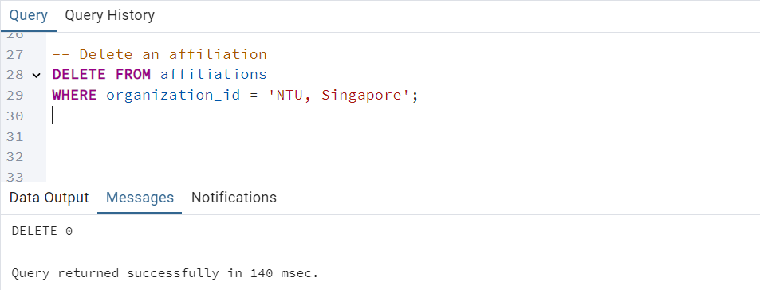

UPDATE QUERY:
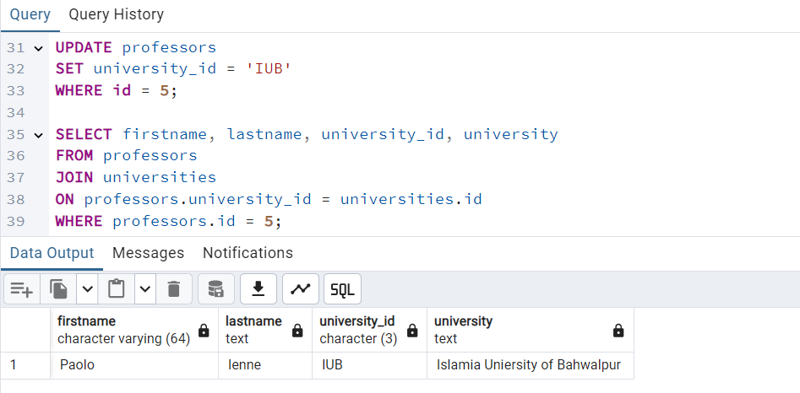

JOINS QUERY:
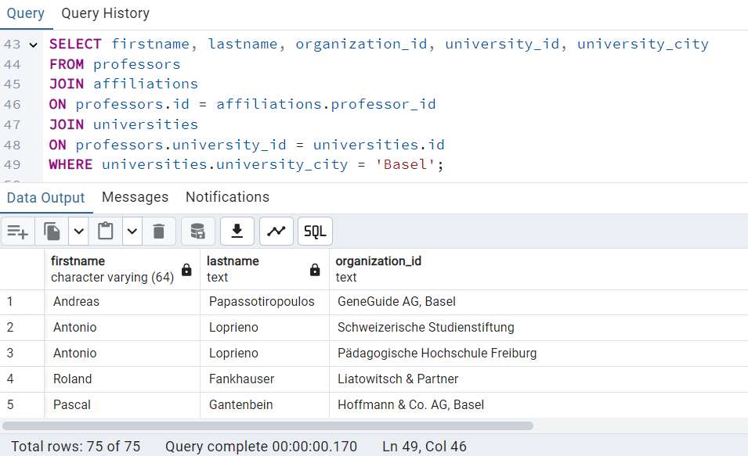

- Project Files
The final project is accessible via the following link.
https://drive.google.com/drive/folders/15bZltclA8WZIW6DOVoYqYFyfnmrqWiku?usp=sharing


